College Degrees and Certifications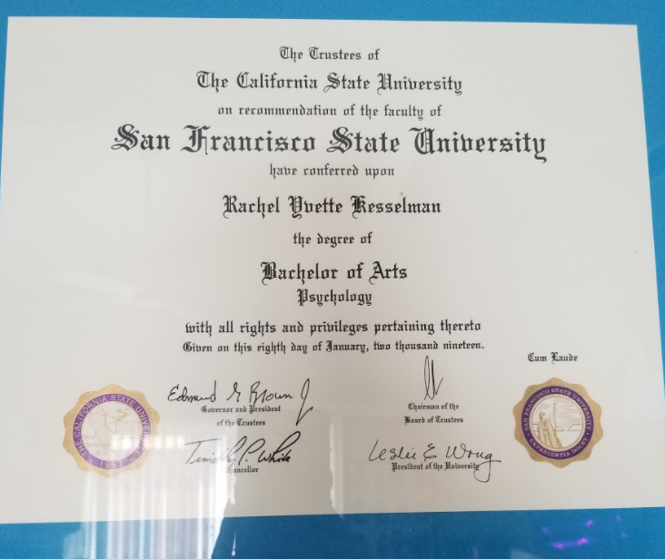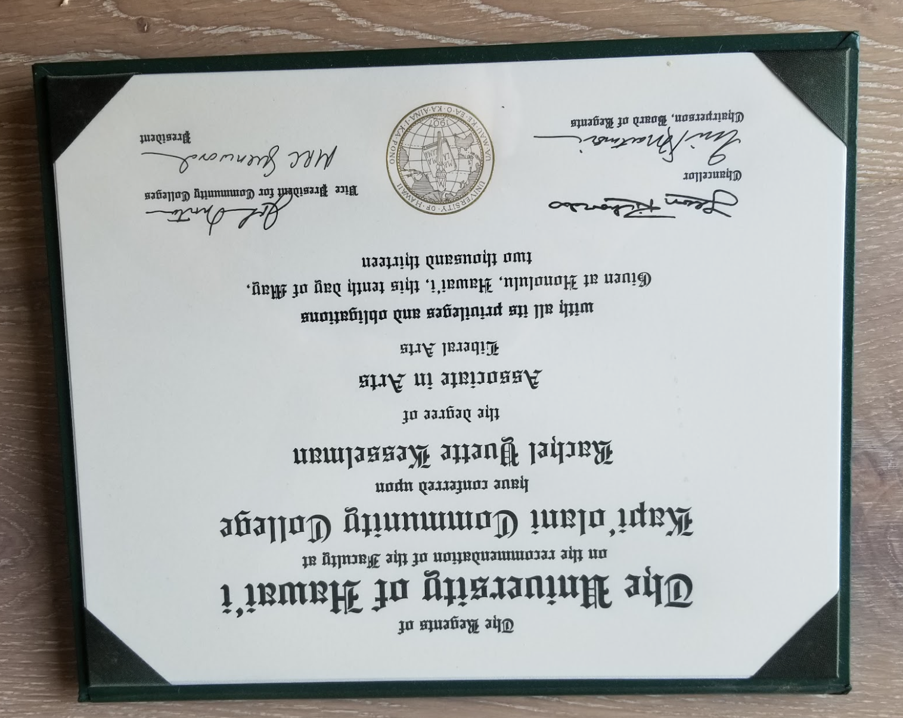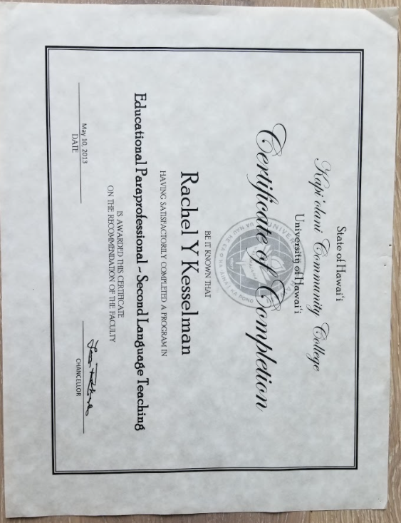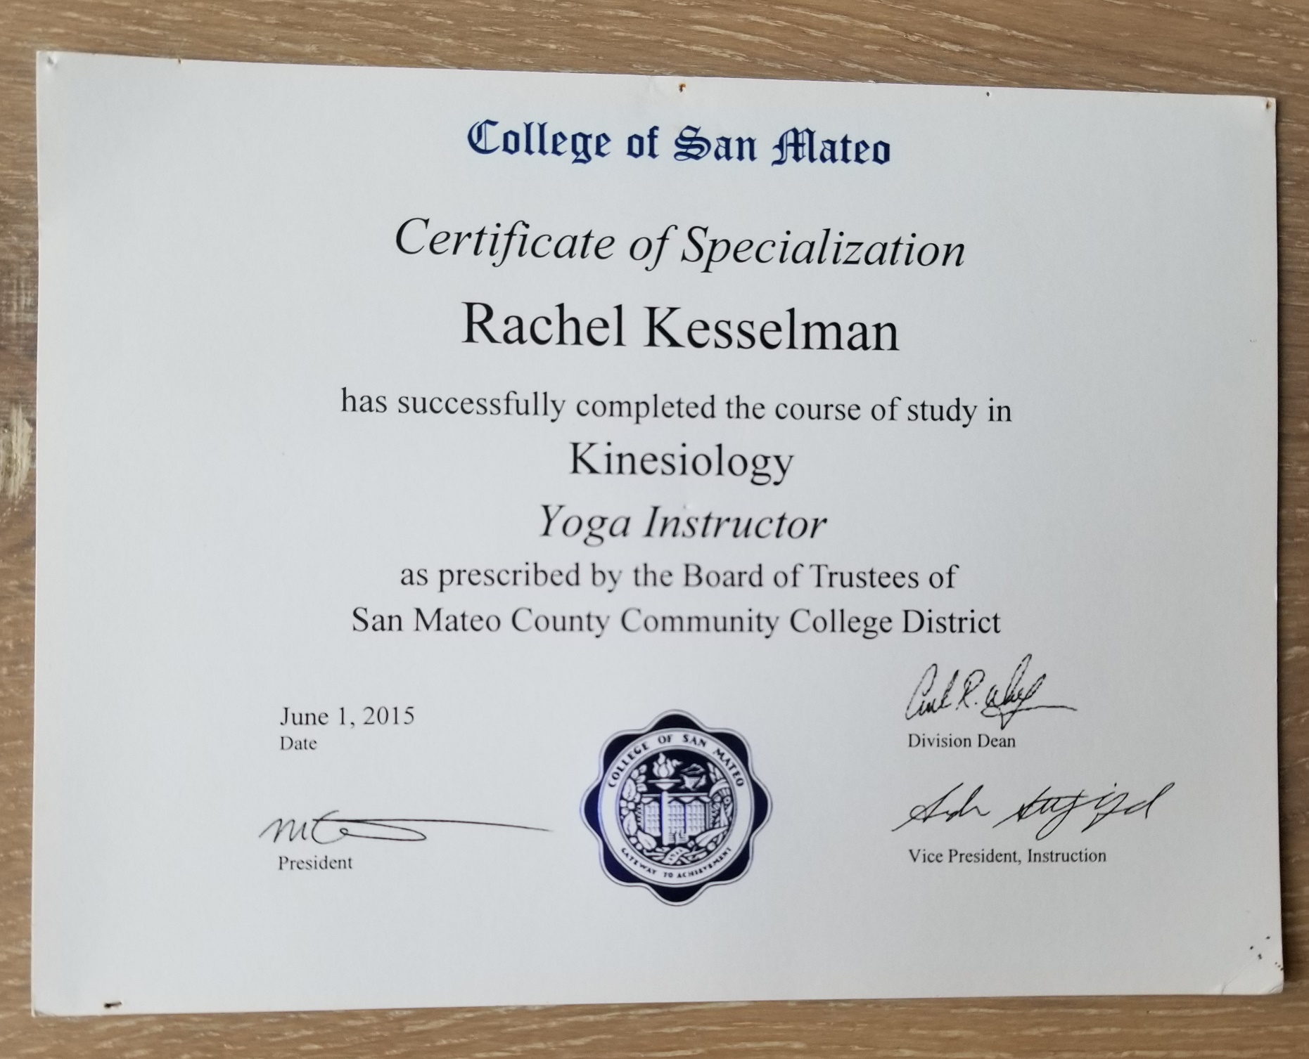Yoga Certifications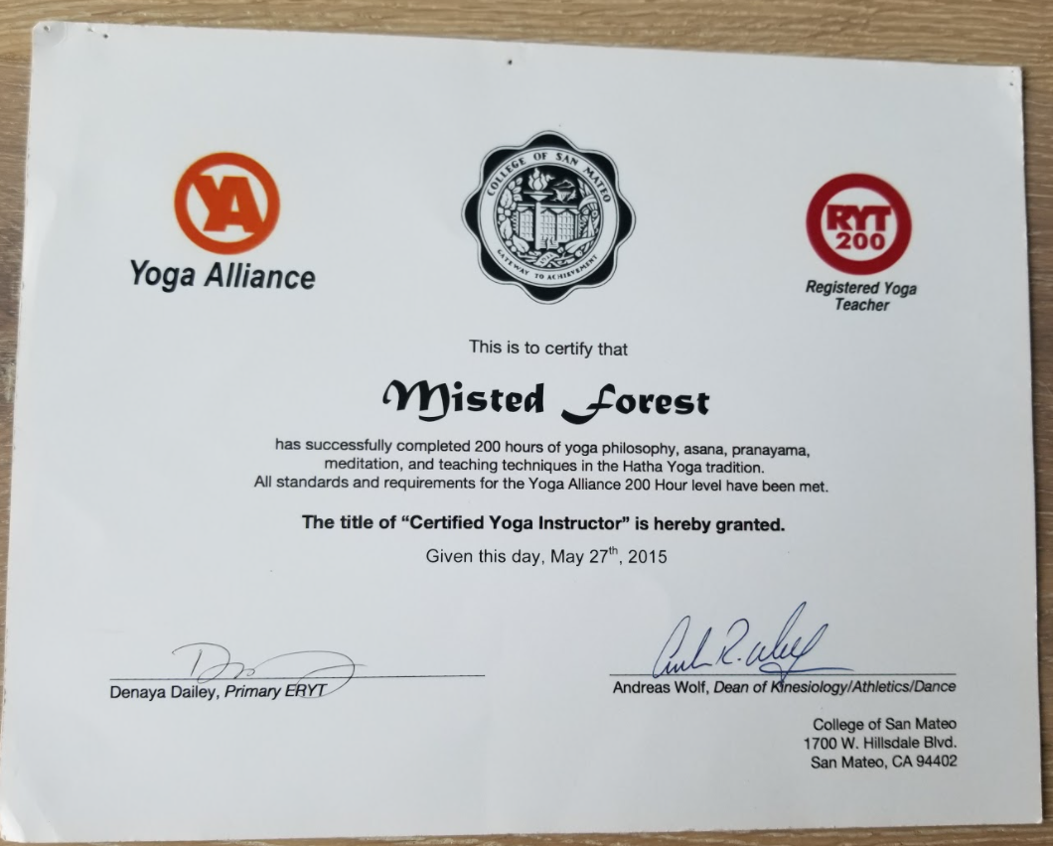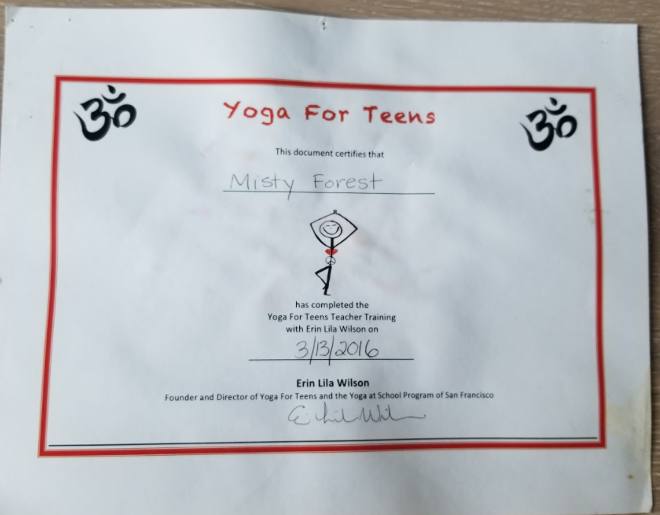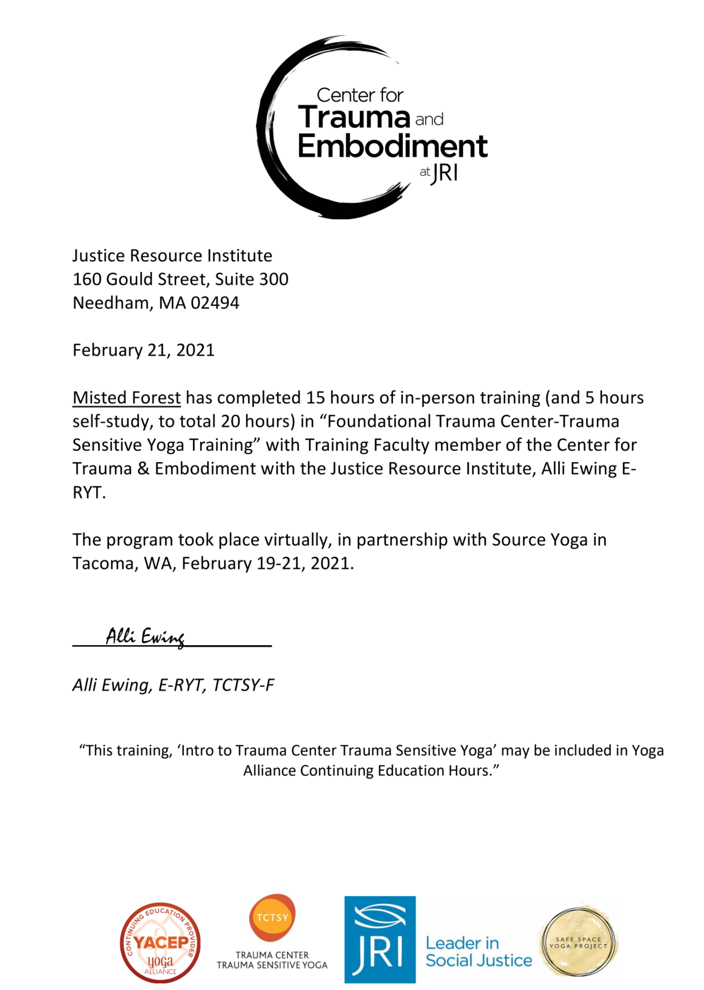
How I utilize this training

I am more aware of systematic oppression and the different societal and cultural expressions of trauma. I learned verbiage and ideas for doing a trauma informed class. I knew a lot of this information in my courses at SFSU in womxn and gender studies as well.

I might do there 300 hour training next summer or at another time. It depends on how my Masters Program goes.
Dance and Martial Arts Awards 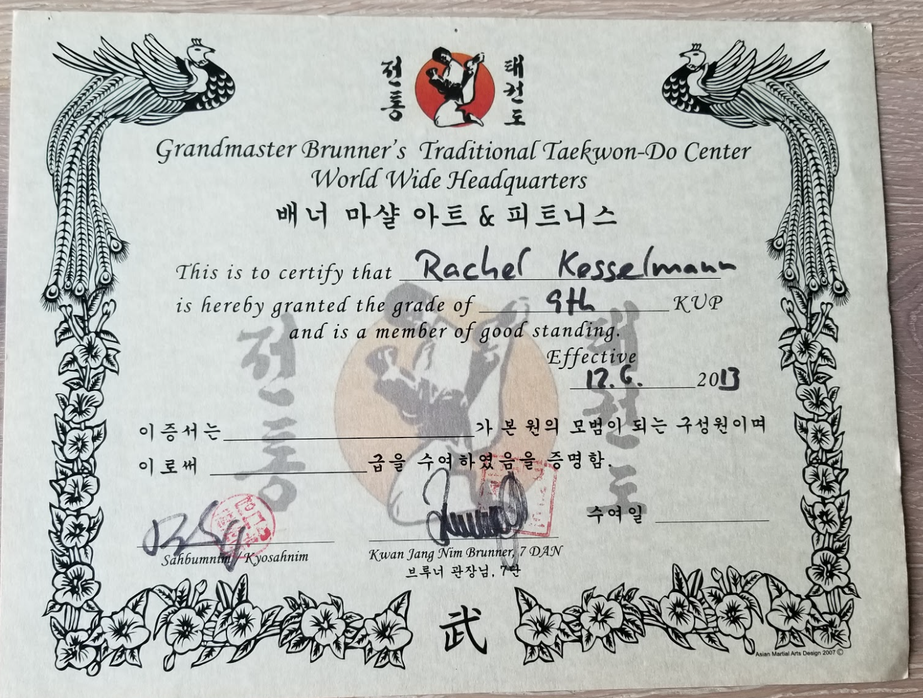

Trained in Taiji Qigong basics and assisted in feeling, cultivating and sending Chi with
Dr.Wimmer at Skyline College

I learned the 8 Brocade.
The 24 forum Shaolin Style
Push and Pull.
Grounding Techniques
Feeling a human hearts magnetic field or (aura)

I use what I learned in some of my yoga/martial arts combined classes.
Also in my intuitive dance/movement classes

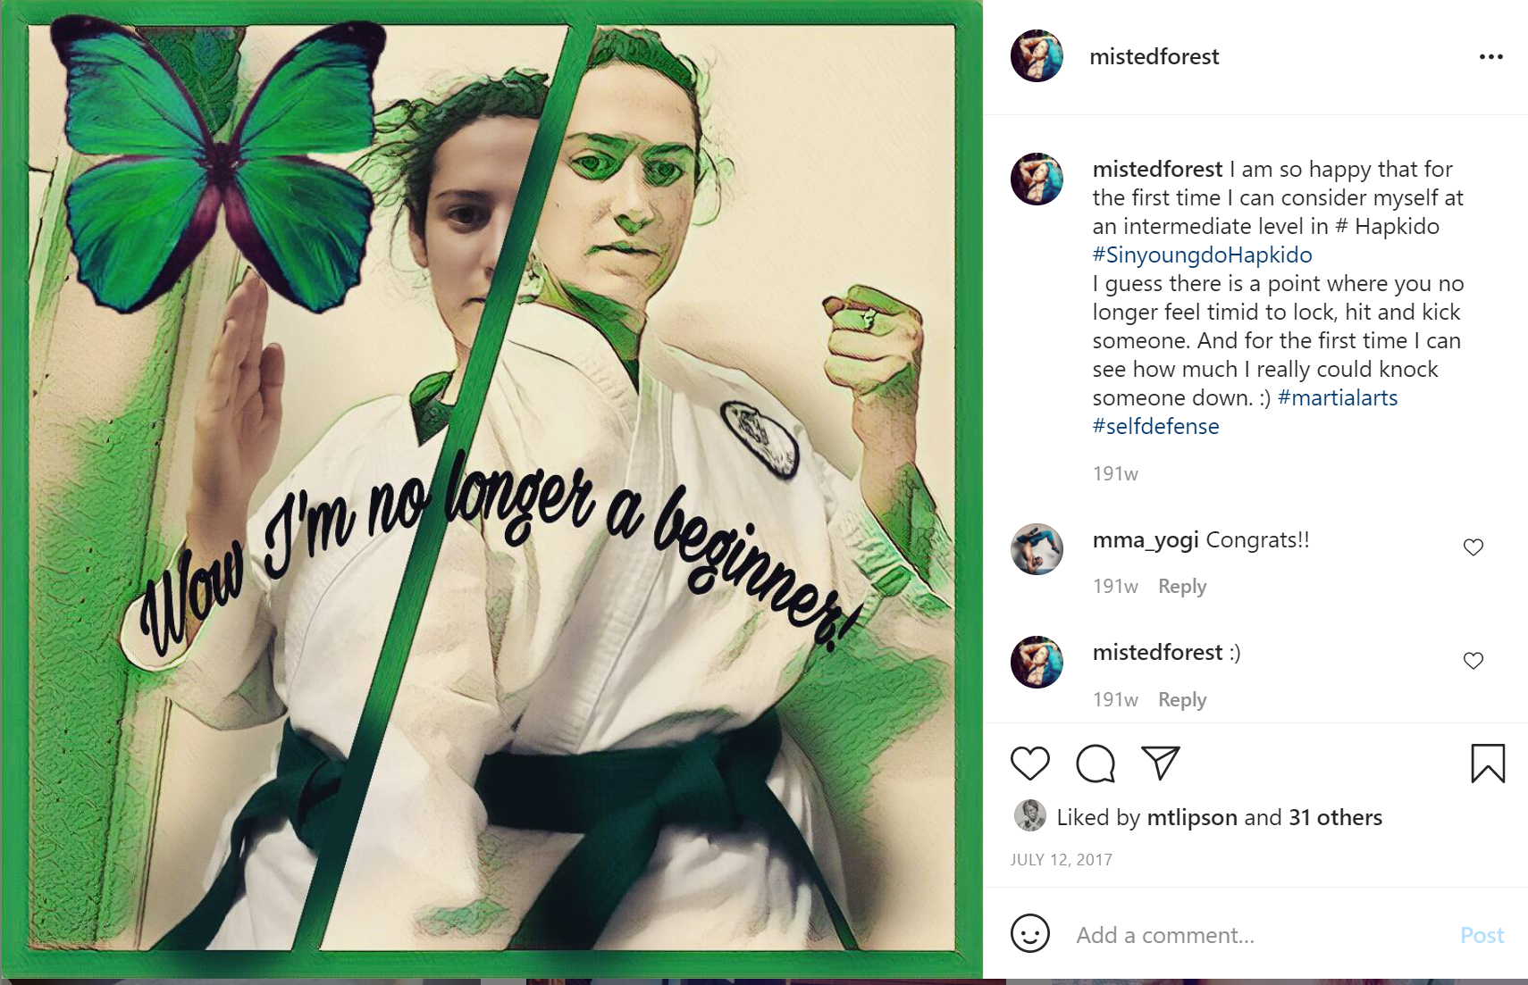
Received my Green Belt in Hapkido
July 2017
Notable Dance Performances and accomplishments 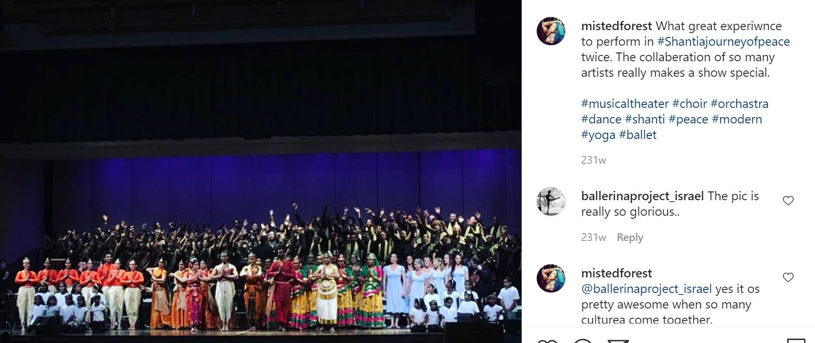

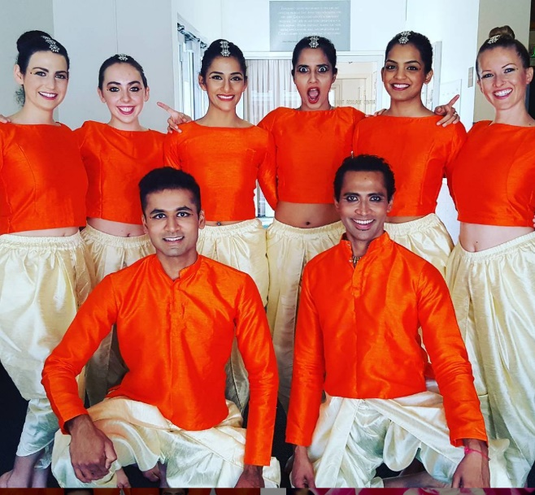
During this time, I was a Dance major at San Francisco State University. I trained on average 13 hours a week in dance (ballet, modern, traditional dance styles like Indian and Korean, as well as Pilates and yoga.) A notable course I took was Dance medicine, where I use many of my assessment techniques with my private clients today.
I would have considered myself a semi professional dancer or part time professional dancer from 2014-2016. I have danced and done dance training since I was 3 years old.
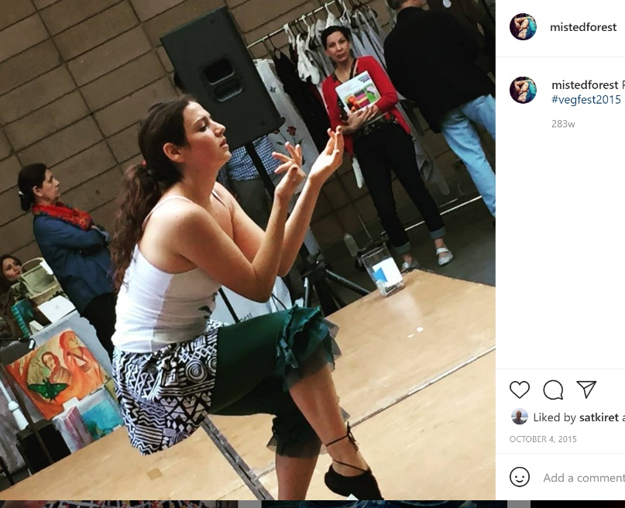
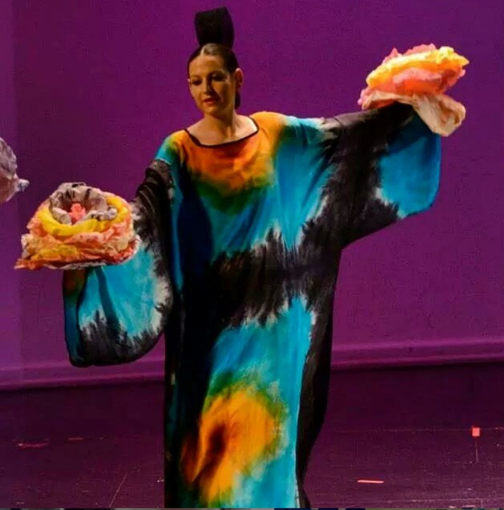
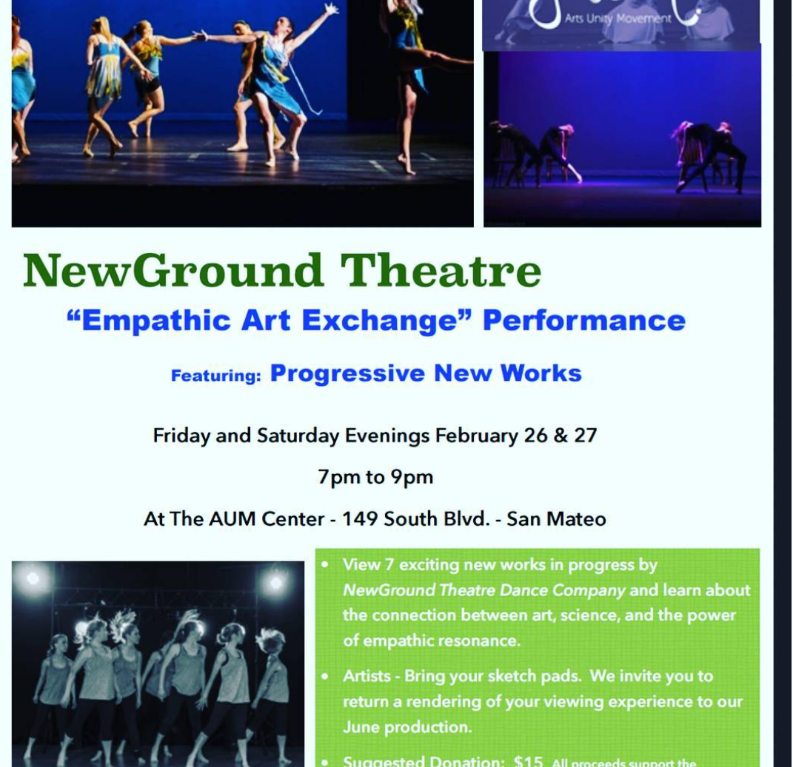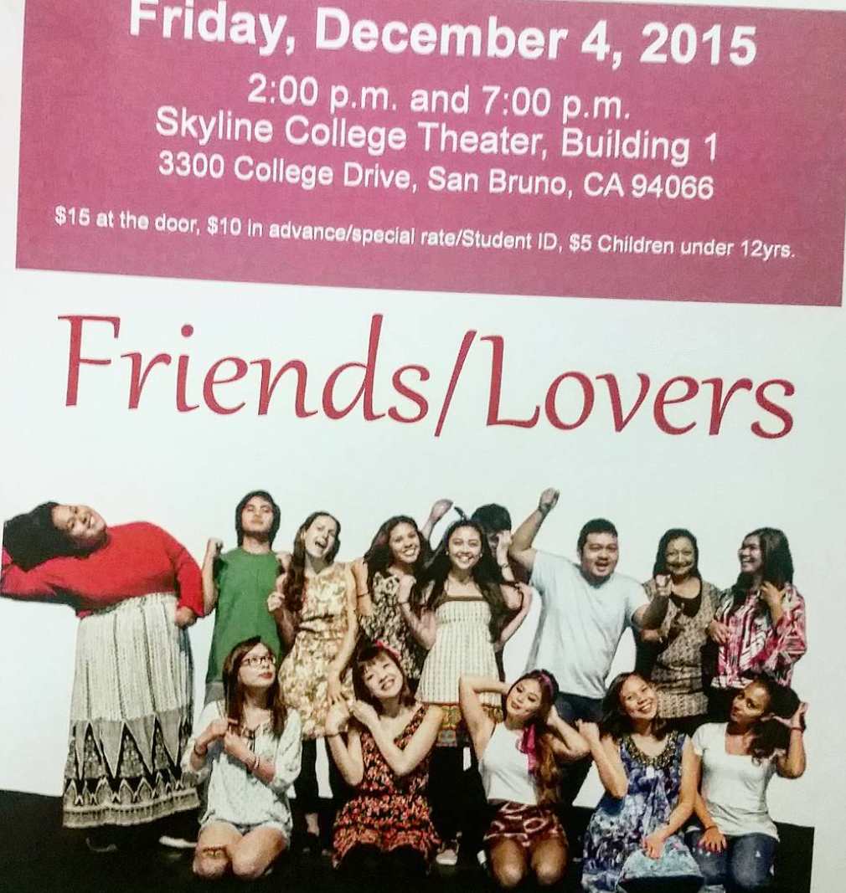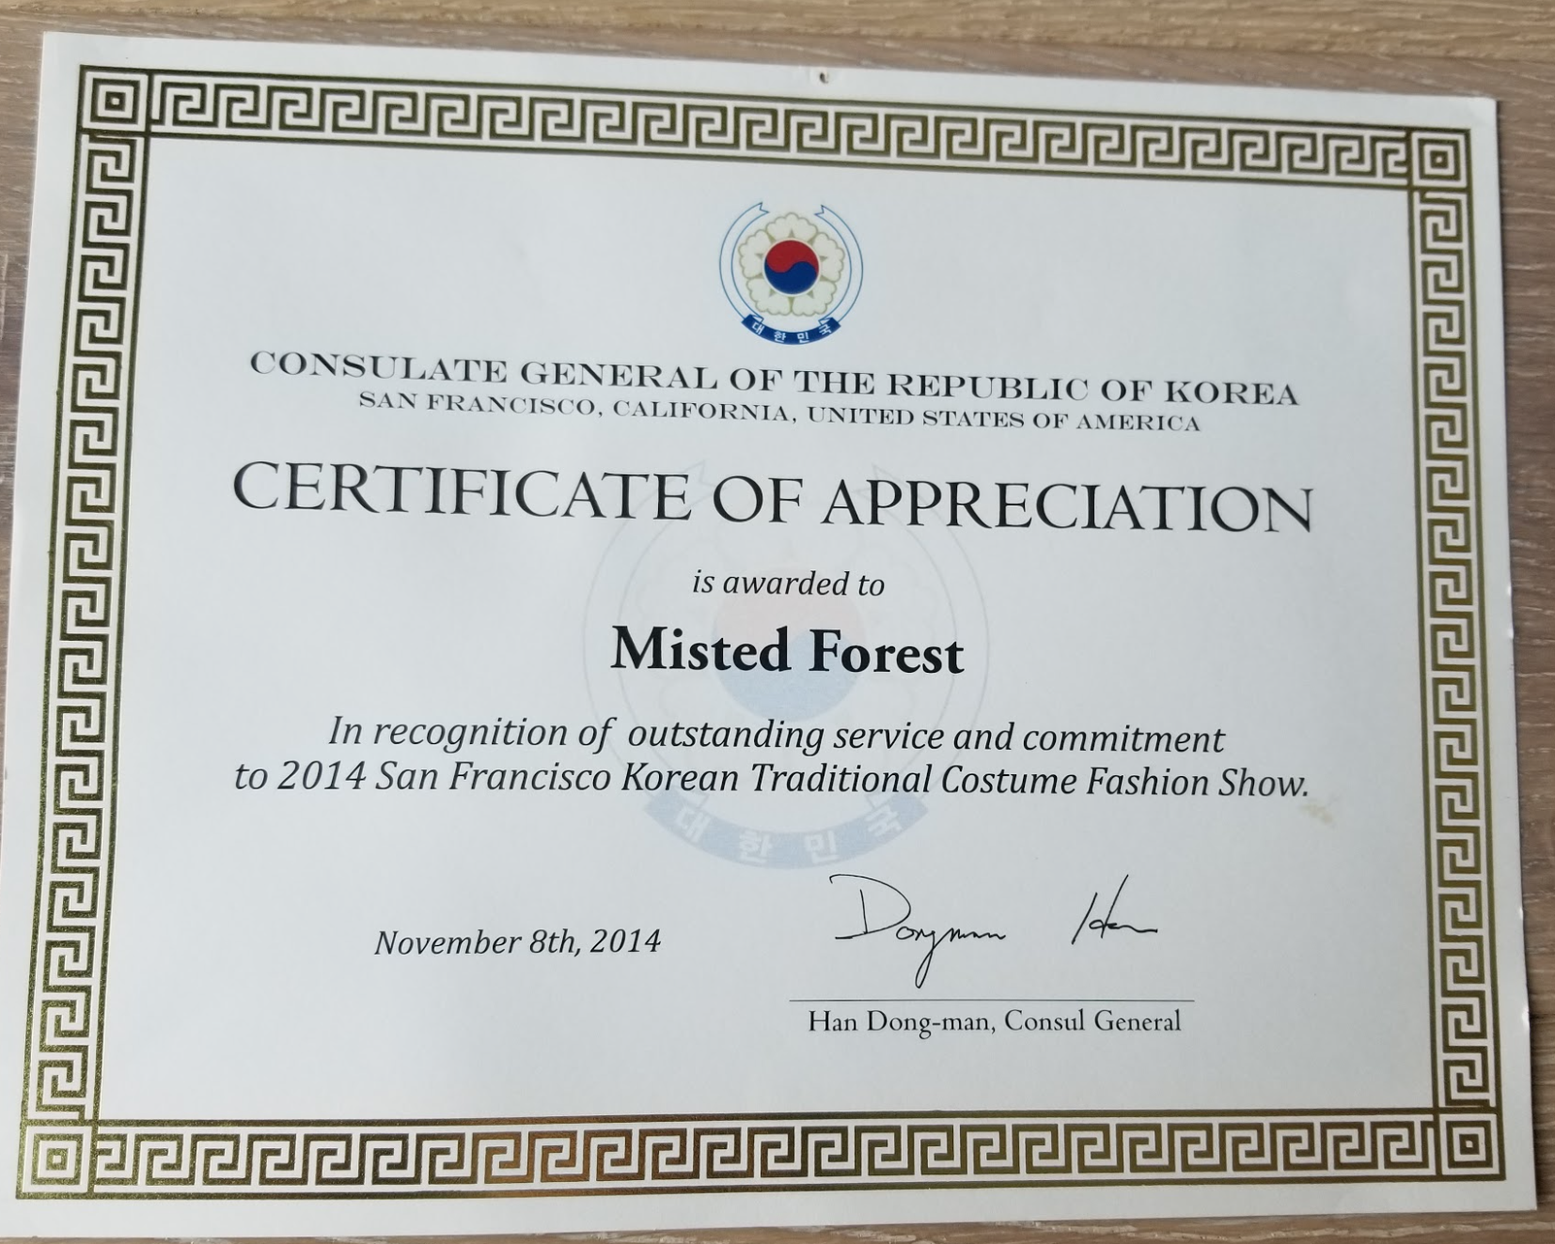

Consciousness and Energy Trainings
Trainings with Dr.Wimmer at Skyline College
- Sound Healing and Consciousness intent college courses
- Intensive PNF training
- Taiji Qigong basics

I have done energetic healing since I was a child. I plan to learn more about this in the future. I find that martial arts and qigong as well as meditation and breathing techniques I teach in yoga are great ways to cultivate lifeforce.

I teach sound healing in my chakra focused classes. Teaching people how to heal their body with the power of their voice. I want to continue training in vocal healing. If you are interested in this subject, I always recommend the global sound healing institute located in Marine County. Their music and sound equipment is the top in the world for sound healing and education.
